1. Created a directory **docker** and created files **basicdetails.html** & a **Dockerfile**

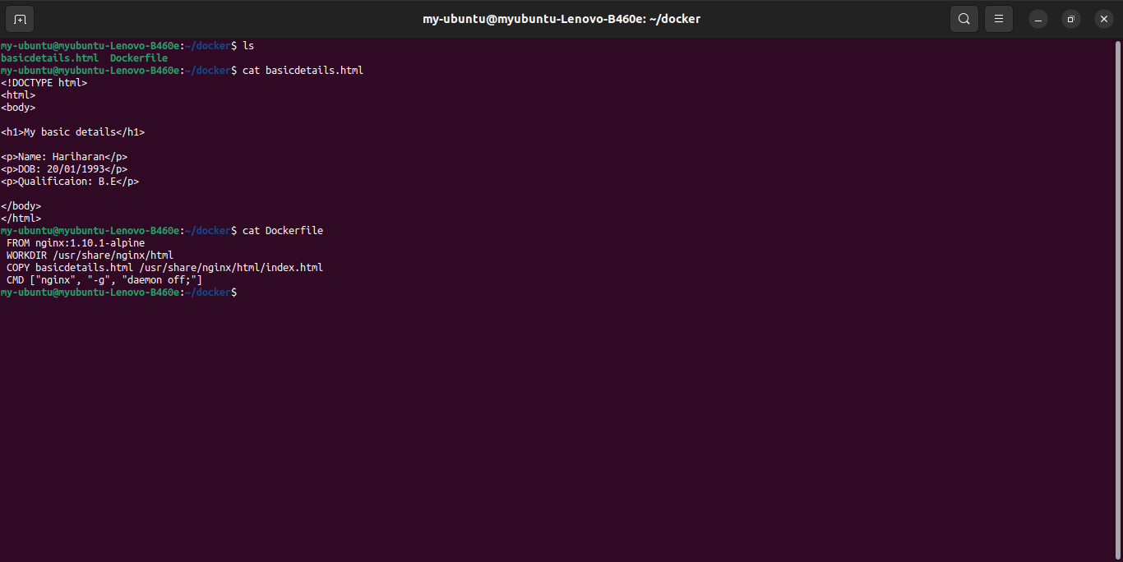

2. Building docker image:

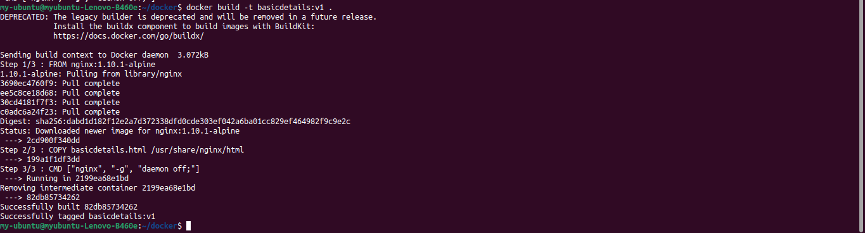

3. Docker image name: basicdetails has been build:



4. Running docker image to build container:

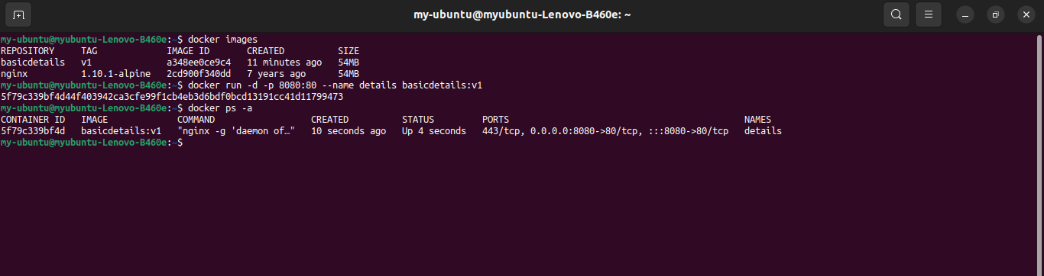

5. Webpage displaying my details:

